**Task 1 Bug Bounties**

target_url = <http://testphp.vulnweb.com/listproducts.php?cat=>

1)

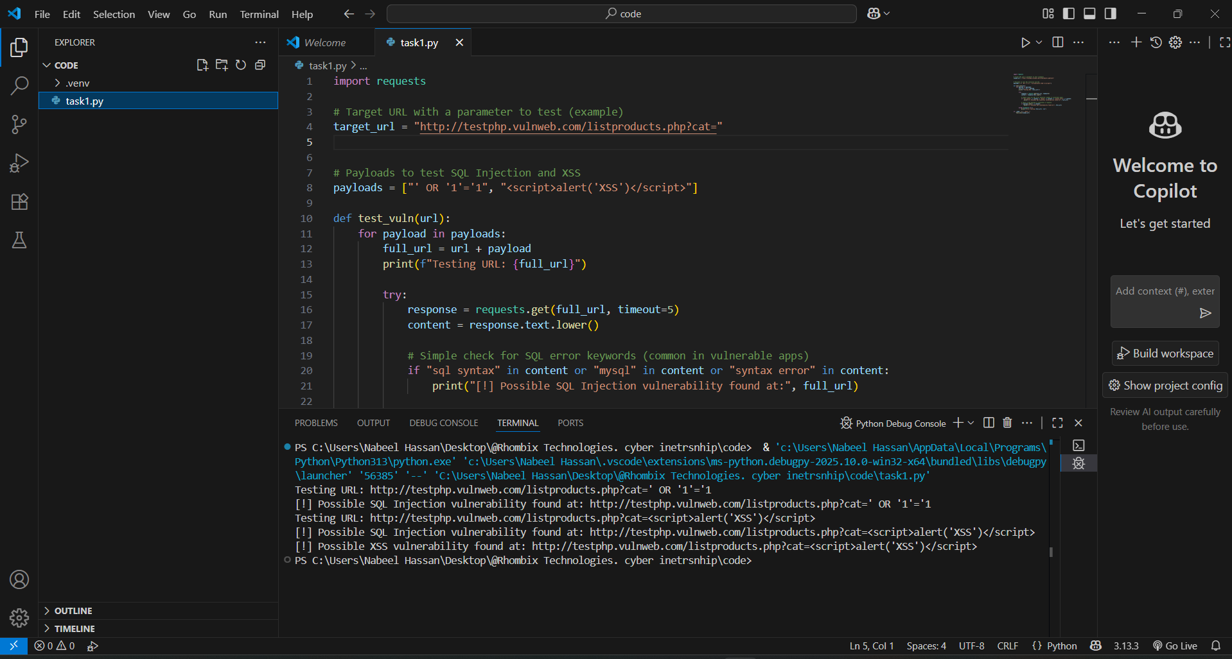

2)

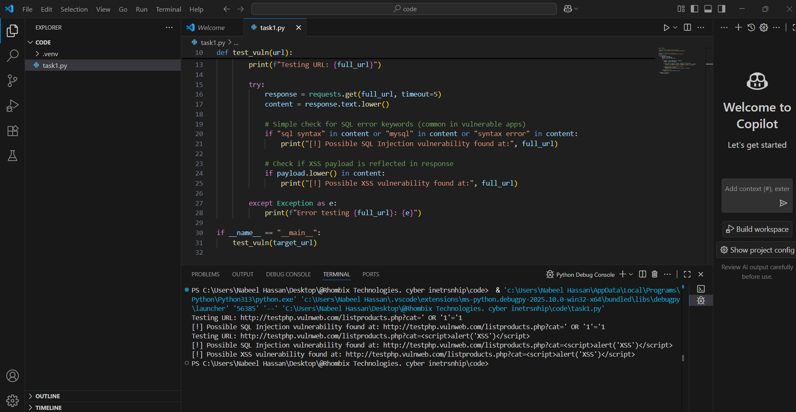

3)

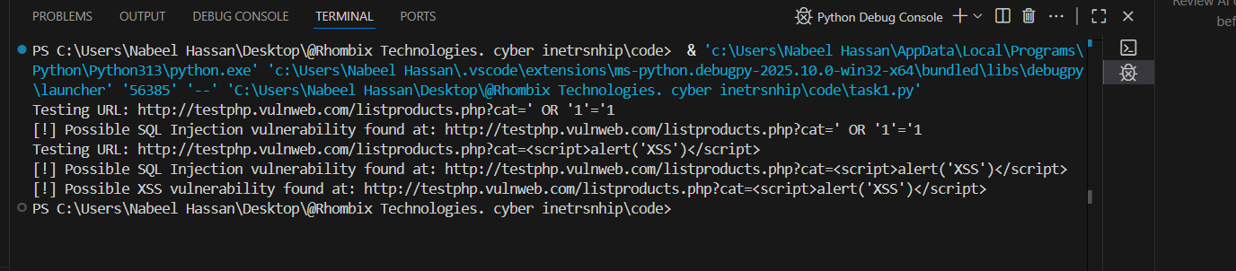

4)

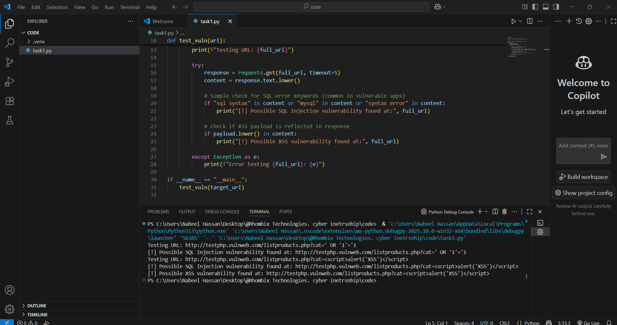

**Task 2 RFID Blocking**

1)

RFID chips in cards/passports emit radio waves to communicate. Unauthorized scanners can capture this data without your consent.

Goal: Create a barrier that blocks these radio waves, preventing unauthorized scanning.

**Materials Needed**

Item Purpose Where to Get

Aluminum foil or conductive fabric Blocks RFID signals by acting as a Faraday cage Grocery store / online

Cardboard or thick paper To form the structure of the sleeve Stationery shop

Tape or glue To secure materials Stationery or hardware store

**Step 1: Cut Blocking Material**

Cut a piece of aluminum foil or conductive fabric about 10 cm x 7 cm (slightly bigger than your card).

This piece will wrap around the card to block RFID signals.

**Step 2: Prepare the Sleeve Base**

Cut a piece of cardboard or thick paper roughly the size of your card (8.5 cm x 5.5 cm approx).

Fold it to make a sleeve — like a small envelope with one open side to insert the card.

**Step 3: Line the Sleeve with Blocking Material**

Wrap or line the inside of the folded cardboard with the aluminum foil or conductive fabric.

Ensure it covers all sides except the opening to fully enclose the card when inserted.

Use tape or glue to secure the foil/fabric firmly to the cardboard.

**Step 4: Insert the RFID Card**

Slide your RFID-enabled card (credit card, passport) into the sleeve.

The aluminum foil acts as a Faraday cage, blocking electromagnetic fields and preventing RFID readers from accessing your card data.

**Step 5: Test the Blocking Effectiveness**

Use an NFC/RFID scanner app on a smartphone or a physical RFID reader.

Try scanning the card inside the sleeve — it should fail to read or show no data.

Scan the card outside the sleeve — it should read normally.

If the scan inside the sleeve works, make sure the foil fully encloses the card with no gaps.

**Optional: Buy RFID Blocking Wallets/Sleeves**

If you prefer not to DIY, many RFID-blocking wallets or sleeves are available online and in stores with tested blocking capability.

**Code:**

**1. Simple NFC Scan Detection Code (Android)**

This example shows how an Android app can detect when an NFC card is scanned by the phone’s NFC reader (just detection, not blocking).

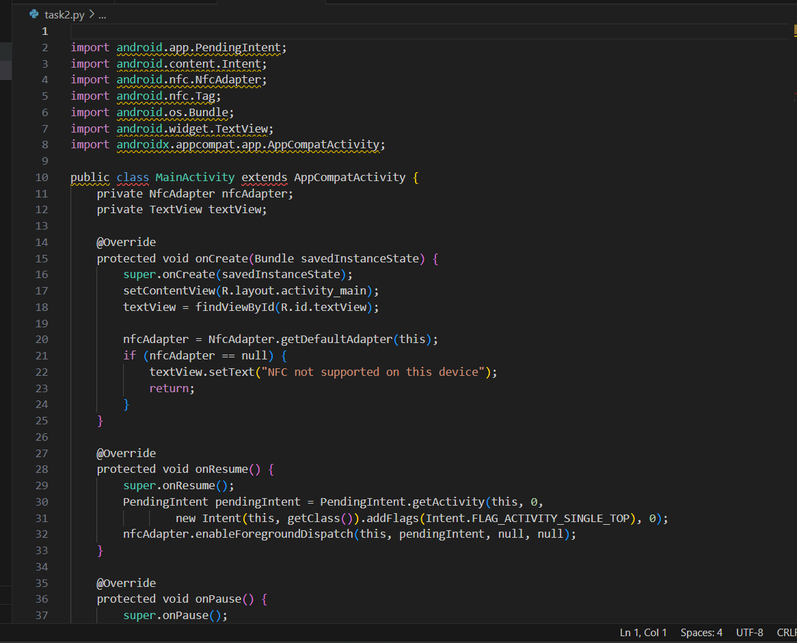

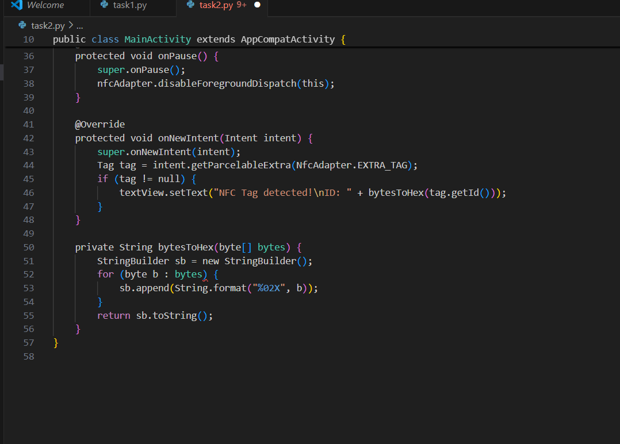

**2. Simulated RFID Blocking Concept in Python**

Since we can't physically block RFID by code, here’s a simulation of detecting unauthorized scanning attempts in a controlled environment (for example, scanning logs).

